**ES6 ASSIGNMENT**



<!DOCTYPE html>

<html>

    <head>

        <title>demo</title>

    </head>

    <head>

    <body>

        <h3>constant declaration</h3>

        <script src=index.js>

        </script>

    </body>

    </head>

</html>

const obj1={

    name:"Aneela"

};

console.log(obj1.name);

obj1.name="Jhansi";

console.log(obj1.name);

**PS C:\Users\aneela\Desktop\node.js\Practise> node index**

**Aneela**

**Jhansi**

**BROWSER OUTPUT:**

**constant declaration**

Aneela  
Jhansi



<!DOCTYPE html>

<html>

    <head>

        <title>demo</title>

    </head>

    <head>

    <body>

        <h3>Variable declaration inside if block</h3>

        <script>

            var a = 1;

            var b = 2;

            if(a===1){

                var a=20;

                let b=10;

                document.write(a,"<br>");

                document.write(b,"<br");

            }

document.write(a,”<br>”);

document.write(b,”<br>”);

        </script>

    </body>

    </head>

</html>

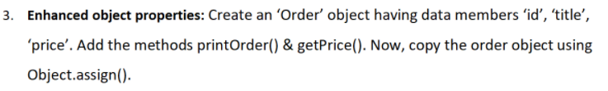

<!DOCTYPE html>

<html>

    <head>

        <title>demo</title>

    </head>

    <body>

        <h3>Enhanced Object Properties</h3>

        <script>

            let Order = {

                id:100,

                title:"Jhansi Aneela",

                price:3000,

                printOrder(){

                    document.write(this.id);

                    document.write(this.title);

                    document.write(this.price)

                },

                getPrice(){

                    document.write(this.id);

                    document.write(this.title);

                    document.write(this.price)

                },

            }

            const obj1 = {};

            const obj2 = Object.assign({},Order);

            document.write(obj2);

        </script>

    </body>

</html>

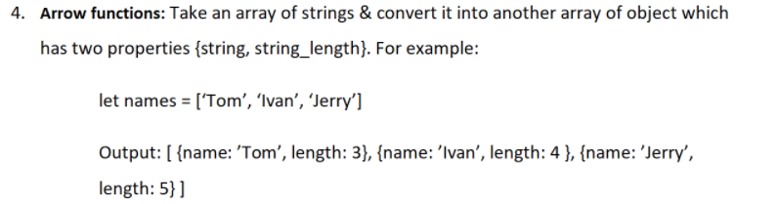

<!DOCTYPE html>

<html>

    <head>

        <title>demo</title>

    </head>

    <body>

        <h3>Arrow functions</h3>

        <script>

            let array = ['Tom','Ivan','Jerry'];

            let newArr = array.map(item => {

                    return {

                        'name': item,

                        'length': item.length

                    }

                })

                document.write(newArr);

        </script>

    </body>

</html>

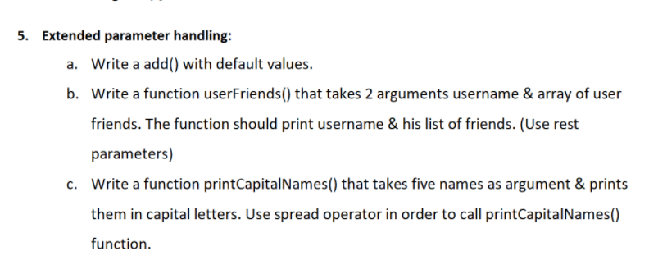

<!DOCTYPE html>

<html>

    <head>

        <title>demo</title>

    </head>

    <body>

        <h3>Extended parameter handling</h3>

        <script src=index.ts></script>

        </script>

    </body>

</html>

let a = function(value=10)

{

    return value;

}

console.log('Default parameter is ' + (a()));

// b)

let userFriends = function(username, ...userfriends){

    this.username = username;

    this.userfriends = userfriends;

    console.log(username,userfriends);

}

userFriends("Aneela","Bhargav","Bhavana","Nikitha");

//c)

const names =["aneela","bhargav","srujana","jyothi","kanna"];

let printCapitalNames = function(){

    const x = names.map(function(name){

        return name.toUpperCase();

    })

    console.log(x);

}

printCapitalNames();



<!DOCTYPE html>

<html>

    <head>

        <title>demo</title>

    </head>

    <body>

        <h3>Template literals</h3>

        <script src=index.ts></script>

        </script>

    </body>

</html>

const names = "Aneela";

const deskno = 100;

const laptopmodel = "hp";

const message = `Hello SYSNET, My name is ${name}, desk number is ${deskno}, and laptop model is ${hp}.

Here i am facing some issue to install the softwares it is asking admin rights to install, will u please resolve this error.

Thanks and regards

Nerella Jhansi Aneela`

console.log(message);

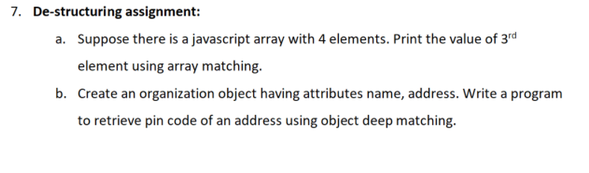

<!DOCTYPE html>

<html>

    <head>

        <title>demo</title>

    </head>

    <body>

        <h3>Destructuring Assignment</h3>

        <script src=index.ts></script>

        </script>

    </body>

</html>

**7-a)**

let friends = ["Aneela","Bhargav","Kanna","srujana"];

let[item1,item2,item3,item4] = friends;

console.log(item3);

**7-b)**

let organization ={

    name: "Aneela",

    address:[{pincode:522426,area:"pylon"}]

}

let {name,address.area,address.pincode} = organization;

console.log(address.pincode);

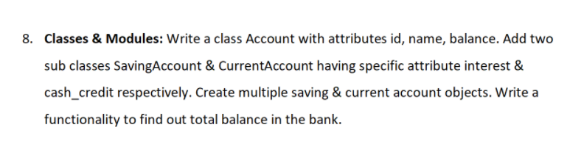

<!DOCTYPE html>

<html>

    <head>

        <title>demo</title>

    </head>

    <body>

        <h3>Classes & Modules</h3>

        <script src=index.ts></script>

        </script>

    </body>

</html>

class Account{

    constructor(id,name,balance)

    {

        this.id = id;

        this.name = name;

        this.balance = balance;

    }

}

class SavingsAccount extends Account{

    constructor(id,name,balance,interest)

    {

        super(id,name,balance);

        this.interest = interest;

    }

    totalBalance = () => { this.balance += this.interest;

        console.log(this.balance);};

}

class CurrentAccount extends Account{

    constructor(id,name,balance,cashCredit)

    {

        super(id,name,balance);

        this.cashCredit = cashCredit;

    }

    totalBalance = () => { this.balance += this.cashCredit;

        console.log(this.balance);};

}

let S1 = new SavingsAccount(1001,'Aneela',40400,4000);

let S2 = new CurrentAccount(10003, 'Bhargav', 30000,3800);

S1.totalBalance();

S2.totalBalance();